ACSL
American Computer Science League
2012 - 2013

Contest #3

Intermediate Division

1.
- Graph Theory
Given the directed graph with vertices A, B, C, D, and E and
directed edges AB, AC, AD, BA, CD, EA, EC, CE, BD, and BE.
How many pairs of vertices have no directed edge?

2.
- Graph Theory
How many paths of length 3 exist in the following directed graph?
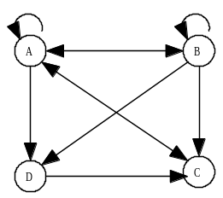

3.
- Boolean Algebra
Simplify the following Boolean expression:

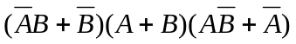

4.
- Boolean Algebra

How many ordered triples make this Boolean expression TRUE?

- What Does This Program Do?
How many of the entries are not 0 after this program is run?
dim a(100)
for i = 2 to 25
a(i)=i
next i
for k = 2 to 25
if a(k) < >0 then
for j = 2*k to 25 step k
a(j)=0
next j
end if
next k

5.

